Milestone Four- Embedded Hardware/ Sodtware Design
Updated Block Diagram:
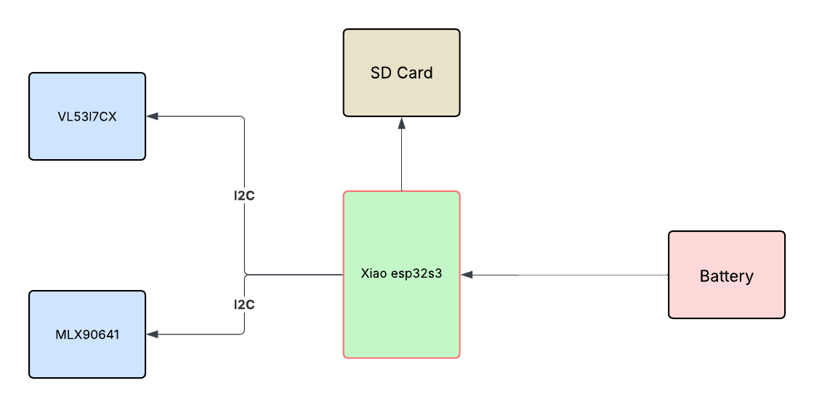

2-
- GND: Connected to the sensor and peripherals as the common ground reference.
- 3V3: Supplies 3.3V power to the sensor and other components.
- D4: Used as the I2C data (SDA) line for sensor communication.
- D5: Used as the I2C clock (SCL) line for sensor communication.
- BAT pads: Used for connecting a battery to power the board when USB is not used.
3-
Our power source is a 3.7V rechargeable LiPo battery connected to the Xiao board’s battery pads. The Xiao board has a built-in voltage regulator, stepping down the battery voltage to 3.3V for the microcontroller and sensors. USB can also supply power during programming or charging. The onboard charging circuit automatically manages battery charging and protection.

